**READING STAGE 6 - 1**

<__question>

Type=1

<__block>

The writer is ?  
<__block>

[A] encouraging gardeners to think about gardens that are drought tolerant  
<__block>

[B] advising gardeners in arid regions on what to grow

<__block>

[C] imploring gardeners to plant more succulent-type plants

<__block>

[D]asking gardeners to reduce the size of their gardens

<__block>

[A]

<__question>

Type=1

<__block>

What would be an important reason for having the cacti

(as shown in the photograph below ) in a raised bed ?

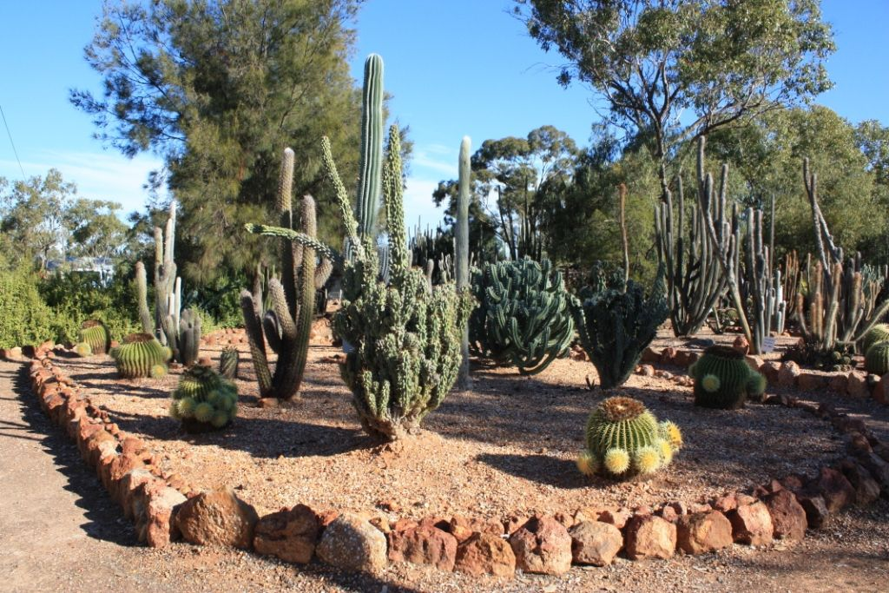

<__block>

[A] it allows for comfortable maintenance

<__block>

[B] it adds to the visual appeal of the garden  
<__block>

[C] it assists in drainage  
<__block>

[D] it prevents the growth of lush weeds

<__block>

[C]

<__question>

Type=1

<__block>

According to the text, which type of garden is often subjected to irregular water supplies ?  
<__block>

[A] botanic gardens

<__block>

[B] cacti gardens  
<__block>

[C] Japanese sand and stone gardens

<__block>

[D] dry riverbed gardens

<__block>

[D]

<__question>

Type=1

<__block>

‘Dry gardens’ are becoming increasingly relevant, not only because of climate change, but because of ?  
<__block>

[A] increased population

<__block>

[B] households using more water per capita  
<__block>

[C] people making larger gardens

<__block>

[D] less people living on suburban blocks

<__block>

[A]

<__question>

Type=1

<__block>

An important purpose of the Royal Botanic Gardens ( Cranbourne) is to ?

<__block>

[A] provide visitors with a fun day out

<__block>

[B] show people who live in arid areas how to have a garden  
<__block>

[C] convince residents from Cranbourne (Vic.) area to change their gardening attitudes  
<__block>

[D] display the wide range of Australian plants and their habitats

<__block>

[D]

<__question>

Type=1

<__block>

The ‘seki tei’-type of garden is designed to ?  
<__block>

[A] maximise water use

<__block>

[B] create a feeling of peace  
<__block>

[C] improve the look of  temples

<__block>

[D] make use of available stones

<__block>

[B]

<__question>

Type=1

<__block>

Which of these gardens, mentioned in the passage, could be called a traditional garden ?

<__block>

[A] the Red Sand Garden

<__block>

[B] the Japanese seki tei  
<__block>

[C] the Arid Garden

<__block>

[D] the Cacti Garden

<__block>

[B]

<__question>

Type=1

<__block>

The Dry River Bed Garden is designed with curved lines to ?  
<__block>

[A] minimise the need for watering  
<__block>

[B] add an attractive feature to the garden

<__block>

[C] replicate the shape of inland rivers  
<__block>

[D] take full advantage of any rainfall

<__block>

[C]

<__question>

Type=1

<__block>

What is a major problem faced by some cacti owners ?

<__block>

[A] they require high maintenance

<__block>

[B] succulents (or spine cushions) are dangerous  
<__block>

[C] over watering

<__block>

[D] the under watering

<__block>

[D]

<__question>

Type=1

<__block>

Which type of garden is **NOT** a minimum-water garden ?  
<__block>

[A] dry river bed gardens  
<__block>

[B] vegetable gardens

<__block>

[C] arid gardens  
<__block>

[D] cactus gardens

<__block>

[B]